Christ at the Centre

Rejoice | Respect | Resilience

St Philip’s Catholic Primary School

Uniform Policy

Statement of Intent
St Philip’s Catholic Primary School believes that a consistent school uniform policy is vital to promote the ethos of the school and provide a sense of belonging and identity for all children, regardless of their protected characteristics or socio-economic circumstances. This policy lays out the measures the school has taken to ensure a consistent, fair and inclusive uniform policy, and to implement a uniform that reflects the needs of all children, and is affordable and the best value for money for the school and children’ families. We believe that children learn most effectively and achieve their best outcomes when they are comfortable and dressed in such a way that sets an appropriate tone for education.

- Legal Framework
This policy has due regard to all relevant legislation including, but not limited to, the following:
• Education and Inspections Act 2006
• Education Act 2011
• Human Rights Act 1998
• Equality Act 2010
• The UK General Data Protection Regulation (UK GDPR)
• Data Protection Act 2018

This policy has due regard to all relevant guidance including, but not limited to, the following:
• DfE (2021) ‘Cost of school uniforms’
• DfE (2021) ‘School Admissions Code’
• DfE (2021) ‘School uniforms’

- Roles and Responsibilities
The governing body is responsible for:
• Establishing, in consultation with the headteacher and school community, a practical and smart school uniform that accurately reflects the school’s vision and values.
• Ensuring that the school’s uniform is accessible and inclusive, and does not disadvantage any pupil by virtue of their protected characteristics or socio-economic status.
• Listening to the opinions and wishes of parents, children and the wider school community regarding changes to the school’s uniform.
• Ensuring that the school’s uniform is accessible and affordable.
• Demonstrating how best value for money has been achieved in the uniform policy.
• Ensuring compliance with the DfE’s ‘Cost of school uniforms’ guidance.

The headteacher is responsible for:
• Enforcing the school’s uniform on a day-to-day basis.
• Ensuring that teachers understand this policy and what to do if a pupil is in breach of the policy.
• Listening to the opinions and wishes of the school community in regard to the school’s uniform and making appropriate recommendations to the governing body.

Staff members are responsible for:
• Ensuring that children dress in accordance with this policy at all times.
• Supporting children who are in breach of this policy.
• Ensuring that children understand why having a consistent and practical school uniform is important, e.g. school identity.

Parents are responsible for:
• Providing their children with the correct school uniform as detailed in this policy.
• Informing the headteacher if their child requires a more relaxed uniform policy for a period of time, including why.
• Ensuring that their child’s uniform is clean, presentable and the correct size.

Children are responsible for:
• Wearing the correct uniform at all times, unless the headteacher has granted an exemption.
• Looking after their uniform as appropriate.
• Understanding and respecting why a school uniform is important to the school, e.g. school identity and community.

- Cost Principles

The school is committed to ensuring that its school uniform is affordable and accessible to all children, and does not place an unreasonable financial burden on parents. The school will assess the overall cost implications of its uniform policy regularly, including prior to making any changes to the school uniform.
When evaluating whether costs are reasonable and proportionate, the school will take into account the opinions and situations of:
• Economically disadvantaged parents.
• Parents with multiple children who are, or will be in the future, children at the school.
• Parents of younger children, as they are likely to grow quickly and require new sets of uniform more frequently.
• Parents of children with protected characteristics that may impact their ability to access the uniform due to costs.
• CLA and PCLA.
The school will evaluate the cost of its uniform based on the overall collection of uniform items that parents would need to purchase for a pupil, rather than on the cost effectiveness of individual items; this will include consideration of the fact that parents will need to purchase multiples of certain items, e.g. shirts and socks, to ensure their child can come to school in clean uniform every day.
The school is committed to meeting the DfE’s recommendations on costs and value for money. Every care is taken to ensure that our uniforms are affordable for all current and prospective children, and that the best value for money is secured through reputable suppliers.

- Equality Principles
The school takes its legal obligation to avoid discriminating against any protected characteristic unlawfully very seriously, and aims to ensure that the uniform policy is as inclusive as possible so that all children are supported to access a school uniform which is comfortable, suitable for their needs, and reflects who they are.
The school will work to ensure that school uniform’s cost does not disproportionately affect any children by ensuring that uniforms for all genders are as equal in price as possible and by adhering to the cost principles laid out in section 3.
The school ensures that children who are required to follow certain dress requirements, e.g. by virtue of their membership of a particular religious or cultural group, are afforded flexibility to allow them to wear a uniform that adheres to their requirements as far as possible. The school endeavours to meet all requests for amendments to the uniform for these purposes; however, will ensure that the needs and rights of individual children are weighed against any health and safety concerns for the entire school community.
Parents’ requests regarding religious clothing are dealt with on a case-by-case basis by the headteacher and governing body.
The school ensures that the needs of children with SEND and/or sensory difficulties are considered in the uniform policy, e.g. ensuring soft, stretchy fabrics and avoiding intricate buttons or hard seams; however, where the needs of these children cannot be met in the standard uniform policy, individual adaptations to the uniform will be considered and permitted wherever possible.

- School Uniform Supplier
Branded school uniform can be purchased from Monkhouses.
Non-branded school uniform can be bought from most supermarkets.

- Uniform Assistance
The school will support any vulnerable families in meeting the costs of uniforms. We have a range of good quality second hand uniform that is provided free of charge to any parent who needs it. Parents are invited to donate their child’s uniform when they no longer need it.

- Non-Compliance
Staff members will support children who do not adhere to the school policy on uniform and will give items of uniform to the child to wear. Parents will usually be consulted on this, unless it is a regular occurrence and parents are aware that this is what happens.

- School Uniform
Reception and KS1:
Our KS1 uniform consists of a school jumper or cardigan.
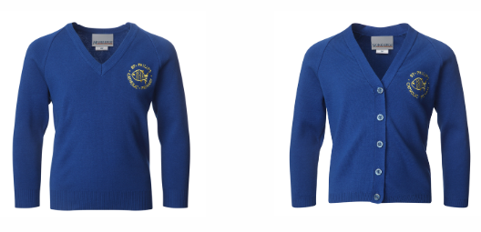
White polo shirt, grey trousers, skirt or pinafore.
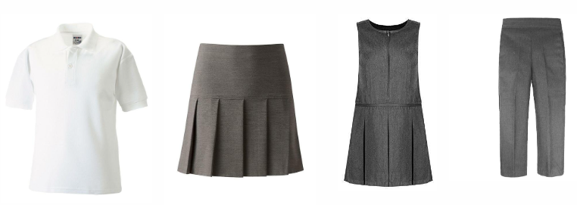

KS2:
Our KS2 uniform consists of a school jumper or cardigan.
White shirt, school tie, grey trousers, skirt or pinafore.
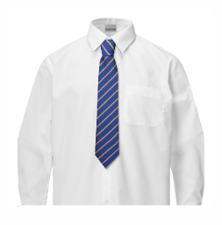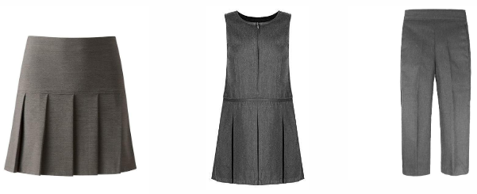
Summer Uniform:
During the summer months, children can wear a blue gingham dress or grey shorts. KS2 children can also wear a white polo shirt without a tie.
P.E. Kit:
Each child should have an indoor and outdoor PE kit with their name clearly labelled in all items. This should be kept in a drawstring P.E. bag.
The indoor kit should consist of a white t-shirt, black shorts and black pumps.
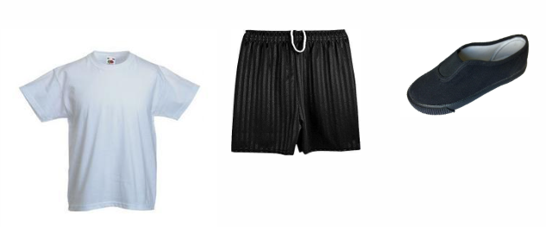
The outdoor kit should consist of a white t-shirt, jogging bottoms, sweatshirt, socks and trainers. Please note that hoodies (zip - up or sweatshirt) are not allowed.

- Jewellery
Permitted jewellery that may be worn is:
• One pair of stud earrings – no other piercings are permitted.
• A smart and sensible wrist watch (not a smart watch. Fitbits are allowed).
Jewellery is the responsibility of the pupil and not the school. Lost or damaged items will not be refunded. All jewellery must be removed during practical lessons, including PE lessons. If earrings cannot be removed, families should provide surgical tape so that these can be covered for safety reasons

- School Bag
If needed, the school bag should be small and plain. Children do not need to bring equipment to school as this is provided.

- Hairstyles
The school reserves the right to make a judgement on where children’ hairstyles or hair colours are inappropriate for the school environment; however, will ensure that any such judgements do not discriminate against any pupil by virtue of their protected characteristics. Each individual pupil’s scenario will be taken into account where any judgements on appropriateness are to be made, and parents will always have the freedom to complain via the school’s Complaints Procedures Policy. Children with long hair must ensure that this does not impede their vision, cover their face or provide a health and safety risk. Long hair must be tied up.

- Makeup
Children are not permitted to wear make-up, nail varnish or fake nails in school.

- Labelling
All children’ clothing and footwear should be clearly labelled with their name. Staff may wish to label clothing where necessary.

14. Monitoring and Review
This policy is reviewed every two years by the Governing Body and the Headteacher.

